**CUSTOMER PORTAL**

Order Balance PHP 50,000.00

Account Balance PHP 75,000.00

INVENTORY LIST

MAKE ORDER

Order History:

Filtering: [10|25|50|100]

|  |  |  |
| --- | --- | --- |
| **Document Number** | **Date** | **Amount** |
| SO 5 | 05/01/2021 | PHP 50,000.00 |
| RC 1 | 04/30/2021 | -PHP 25,000.00 |
| SO 4 | 04/01/2021 | PHP 25,000.00 |
| SO 3 | 03/01/2021 | PHP 25,000.00 |
| SO 2 | 02/01/2021 | PHP 25,000.00 |
| SO 1 | 01/01/2021 | PHP 25,000.00 |

INVENTORY LIST

MAKE ORDER

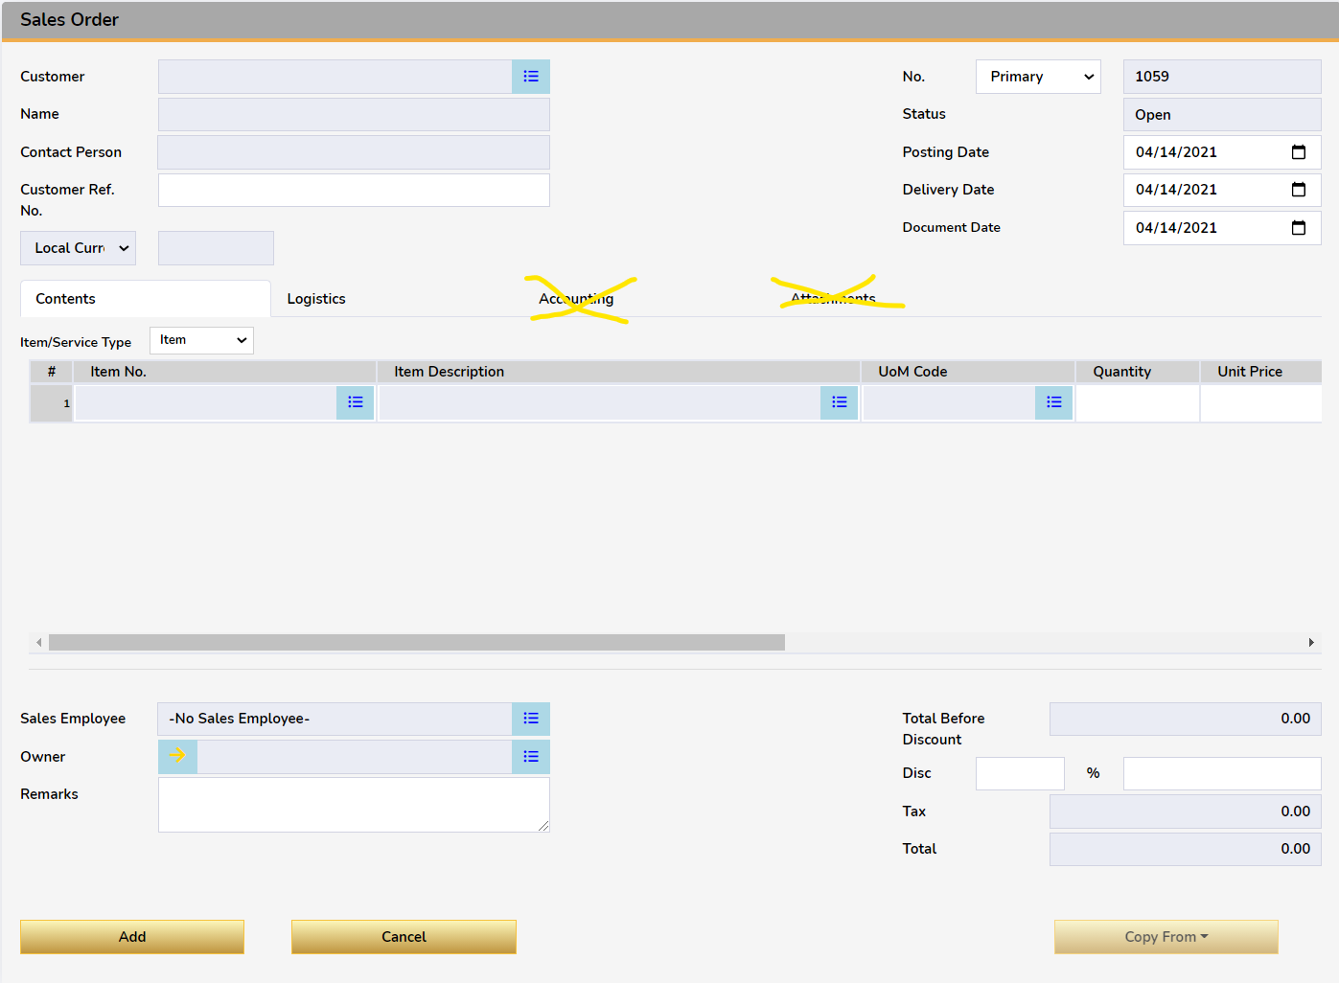

Login issues

1. Isa pang external database
2. Wag na ilabas list ng database,
3. Cardcode ang user code

Additional Notes

rush before tuesday

-pricelist per item

-remove goldern on customer

-remove field owner replace mo ng null, ownercode set to null n lng

-discounts pakidisable

-unit price, disable mo

-tax code, hide mo

-net total hide mo

-hide UDF mo

-service type, disable mo

-sales employee, remove button ung nakadefault lng ang ilabas mo

-posting date and document - disabled, always current date

-hide currency

-paiksian mo ung itemcode column at ung description nya - wag na paikliin kasi sakto na bilang ng column sobra sa space

-copy from alisin mo

-bill to hide mo

-shipping type pwede wala laman depende sa default ni BP

-account balance when clicked, show modal of list of ar invoices tagged to logged in customer

-Ung in stock na column ang laman nya is ung instock minus committed sa OITW

pag nag negative dapat 0 lalabas.

-home button on SO, ITL

-change password on next log in, checkbox un User Management Module